Partnership Social Media and Email Guide

During the week of September 18, 2017, the DC Tobacco Free Coalition (DCTFC), the District of Columbia Department of Health (DOHDC), and local health care organizations, businesses, and civic leaders will come together for “DC Calls It Quits Week,” an awareness campaign about the importance of quitting smoking. Smoking is the leading cause of preventable death and disease in the U.S. In D.C. alone, smoking kills 800 residents each year.

In preparation for DC Calls It Quits Week, the DC community must be made aware of the available partnership opportunities during the week to help city residents connect with resources to quit. In order to do this, the coalition and current DC Quits partners can engage on social media and email to promote potential partners’ event opportunities during DC Quits Week.

This guide includes:
- Sample tweets and Facebook posts to put out in the weeks leading up to and during DC Quits Week
- A sample email to send to potential partners asking them to participate in DC Quits Week
- A sample newsletter write-up for partners to include in order to promote their participation in the event
- Sample graphics to insert in the tweets and Facebook posts (right click the graphic, save it, and insert into the post)

Campaign Hashtag: #DCQuits
Other Relevant Hashtags: #Smokefree, #TobaccoFree

Sample Tweets:

- Proud to join @DOHDC & @DCTFC1 for #DCQuits Week. Help educate DC residents on the dangers of tobacco. http://www.dctfc.org/dc-calls-it-quits-week-2017/

- Nearly 7 in 10 adults would like to quit smoking. Join @DCTFC1 for #DCQuits to help DC residents quit - learn more: http://www.dctfc.org/dc-calls-it-quits-week-2017/

- We have decided to partner with @DCTFC1 to host a DC Quits Week event, hope you can join! #DCQuits http://www.dctfc.org/dc-calls-it-quits-week-2017/

- On Sept 18 @DCTFC1 kicks off #DCQuits 2017. You can be a part of it. Join us to attend a Quits Week event: http://www.dctfc.org/dc-calls-it-quits-week-2017/

- Make a difference for DC smokers & join for #DCQuits week. Use the link below to register. #TobaccoFree http://www.dctfc.org/dc-calls-it-quits-week-2017/

- Be a part of #DCQuits Week with us! We are partnering with @DCTFC1 to host an event; hope you can join! http://www.dctfc.org/dc-calls-it-quits-week-2017/

- There are over 89,000 adult smokers in DC. Join @DCTFC1 for #DCQuits 2017 to help end smoking in the district http://www.dctfc.org/dc-calls-it-quits-week-2017/ [INSERT GRAPHIC]

- Smoking is the leading cause of preventable death. Join @DCTFC1 for #DCQuits 9/18-9/22 to help end smoking in DC http://www.dctfc.org/dc-calls-it-quits-week-2017/ [INSERT GRAPHIC]

- 68.2% of smokers tried to quit in '15 – let’s help them get there in '17! Join us @ #DCQuits & help DC quit smoking http://www.dctfc.org/dc-calls-it-quits-week-2017/ [INSERT GRAPHIC]

- E-cigs are popular among HS students, but they are still damaging to your health. Join us for #DCQuits to learn more http://www.dctfc.org/dc-calls-it-quits-week-2017/ [INSERT GRAPHIC]

Sample Facebook Posts:

- Each year, 800 DC residents die because of smoking. We have joined the DC Department of Health for #DCQuits Week to prevent this number from getting any higher. Join us and learn more at http://www.dctfc.org/dc-calls-it-quits-week-2017/

- Be a part of DC Calls It Quits! Week: join us during #DCQuits Week to learn more about the dangers of tobacco. You can visit http://www.dctfc.org/dc-calls-it-quits-week-2017/ to learn more and register for an event!

- The Week of September 18-22, 2017 is DC Calls It Quits! Week. We are partnering with the DC Tobacco Free Coalition and the DC Department of Health to host a community event during the week. Quits Week is a public awareness campaign aimed at informing residents about the importance of quitting smoking. Join us in encouraging DC residents to quit smoking and learn more here: http://www.dctfc.org/dc-calls-it-quits-week-2017/

- Did you know that smoking is the leading cause of preventable death in the US? We have partnered with the DC Tobacco Free Coalition and the DC Department of Health to change the conversation during DC Calls It Quits! Week. During this week, we will be hosting a community event. For more information, visit the event sign-up page at http://www.dctfc.org/dc-calls-it-quits-week-2017/. [INSERT GRAPHIC]

- The rate of adult smokers in D.C. that tried to quit in 2015 is 68.2%. In fact, over 4,000 calls were made to the DC Quitline in 2016. The week of September 18-22, 2017 is DC Calls It Quits! Week, and we want to encourage all smokers in DC to call the Quitline and quit smoking! Join us and learn more about the events taking place throughout the city #DCQuits http://www.dctfc.org/dc-calls-it-quits-week-2017/. [INSERT GRAPHIC]

Sample Email to Potential Attendees:

Dear XXXX,

On September 18 through 22, 2017, [INSERT ORGANIZATION NAME] is partnering with the District of Columbia Department of Health (DOHDC), the DC Tobacco Free Coalition, and local organizations in the District of Columbia to sponsor DC Calls It Quits! Week. DC Quits Week is a public city-wide awareness event aimed at informing residents about the importance of quitting smoking. As you probably already know, smoking is the leading cause of preventable death and disease and a major health threat for Washington, DC residents.

As a partner of DC Calls It Quits Week, we are hosting an event for our community to spread awareness about the consequences of tobacco in all of its forms and how residents can connect with the resources they need to quit. We encourage you to join us for this event and to spread the word to others in the community who may be interested in or who could benefit from this event.

We hope you can join us during DC Calls It Quits Week! To register and learn more about all the community events taking place during DC Calls It Quits! Week, please visit the event calendar at dcquits.org.

Thank you,

[INSERT YOUR NAME]

Sample Newsletter Write-Up:

It is important that a wide audience is reached, and in order to do that, the DCTFC asks that you include a small section about DC Calls It Quits! Week in your company newsletter. We suggest that you write:

On September 18 through 22, 2017, [INSERT ORGANIZATION NAME] is partnering with the District of Columbia Department of Health (DOHDC), the DC Tobacco Free Coalition, and local organizations in the District of Columbia to sponsor DC Calls It Quits! Week. DC Quits Week is a public city-wide awareness event aimed at informing residents about the importance of quitting smoking. By partnering with the DC Tobacco Free Coalition for #DCQuits Week, we will be hosting an event to spread awareness about tobacco and all its forms. Come join us for our event on [INSERT DATE] from [INSERT TIME] at [INSERT LOCATION]. Please go to dcquits.org for more information.

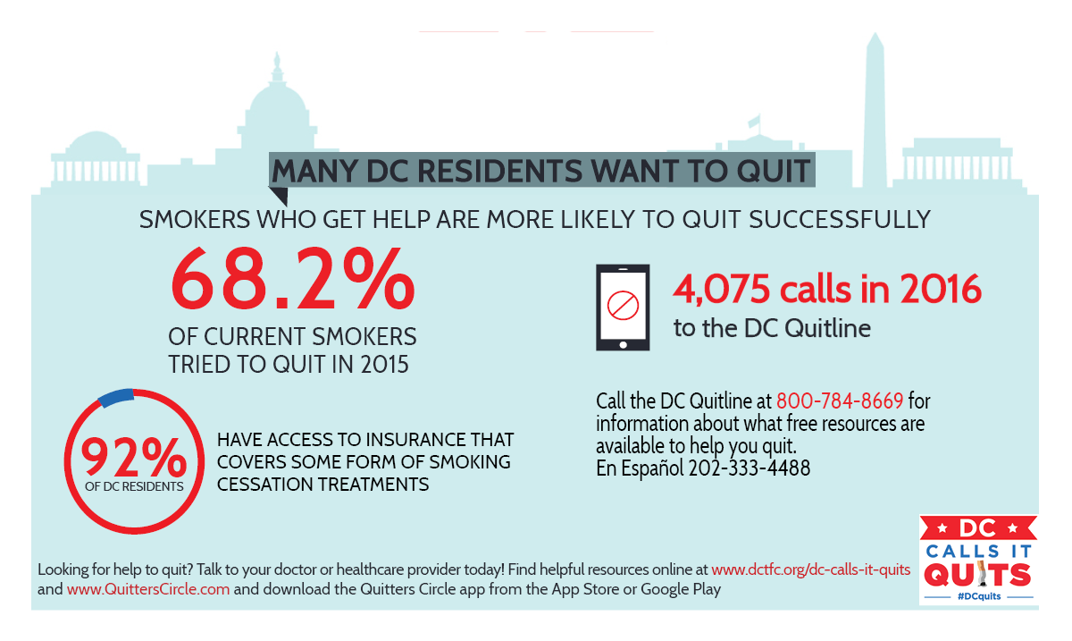
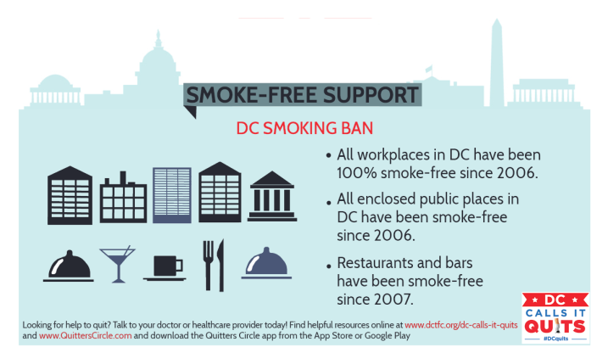
Sample Graphics:

